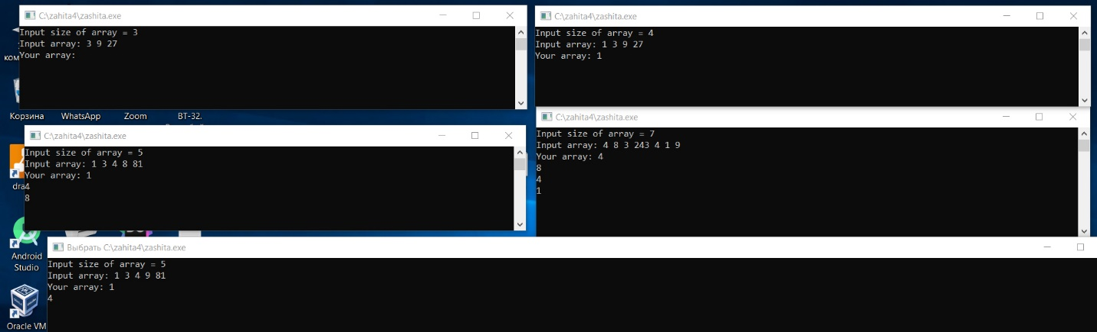

.386 ; Тип процессора

.model flat, stdcall ; Модель памяти и стиль вызова подпрограмм

option casemap: none ; Чувствительность к регистру

; --- Подключение файлов с кодом, макросами, константами, прототипами функций и т.д.

include c:\masm32\include\windows.inc

include c:\masm32\include\kernel32.inc

include c:\masm32\include\user32.inc

include c:\masm32\include\msvcrt.inc

; --- Подключаемые библиотеки ---

includelib c:\masm32\lib\user32.lib

includelib c:\masm32\lib\kernel32.lib

includelib c:\masm32\lib\msvcrt.lib

; --- Сегмент данных ---

.data

i_invite db "Input size of array = ", 0

i_d db "Input array: ", 0

fmt db "%d", 0

msg db "Your array: ", 0

fmtout db "%d", 13, 10, 0

.code

; void enter_arr(int *arr, size_t n);

enter_arr proc

pushad

push offset i_d

call crt_printf

add esp, 4

mov eax, [esp+36] ; eax = arr

mov ecx, [esp+40] ; ecx = n

cmp ecx, 0

jle retl

loop1:

push eax ; сохраняем eax

push ecx

push eax

push offset fmt

call crt_scanf ; вводим *arr

add esp, 8

pop ecx

pop eax

add eax, 4 ; arr = arr + 4

loop loop1

retl:

popad

ret 8

enter_arr endp

is_pow_3 proc

push ebx

mov eax, [esp+8] ; eax = x

cmp eax, 1 ; если x = 1, вернуть ложь

jle ret0

;степень тройки если eax and 11b = 0

and eax, 11b ; eax = eax AND ebx

cmp eax, 0

je ret0

jmp ret1

ret0:

mov eax, 0

jmp retlb

ret1:

mov eax, 1

retlb:

pop ebx

ret 4

is_pow_3 endp

; void del_3(int *adr, size_t *pn);

del_3 proc

pushad

mov ebx, [esp+36] ; eax = adr

mov ecx, [esp+40] ; ecx = pn

push [ecx]

mov esi, 0 ; esi = i - индекс прохода по массиву

mov edi, 0 ; edi = j - индекс записи элементов

mov [ecx], esi

pop ecx

cmp ecx, 0

jle retl

loop1:

push dword ptr [ebx+esi*4]

call is_pow_3

cmp eax, 0

jne nwrite

mov eax, [ebx+esi*4]

mov [ebx+edi*4],eax ; adr[j] = adr[i]

inc edi ; j++

mov edx, [esp+40]

mov [edx], edi ; *pn = j

nwrite:

inc esi ; i++

loop loop1

retl:

popad

ret 8

del_3 endp

out_arr proc

pushad

mov eax, [esp+36]

mov ecx, [esp+40]

cmp ecx, 0

jle retl

loop1:

push eax

push ecx

push [eax]

push offset fmtout

call crt_printf

add esp, 8

pop ecx

pop eax

add eax, 4

loop loop1

retl:

popad

ret 8

out_arr endp

start:

mov eax, offset fmtout

add eax, 5

push eax

push offset i_invite

call crt_printf

add esp, 4

pop eax

push eax

push eax

push offset fmt

call crt_scanf

add esp, 8

pop eax

push [eax]

add eax, 4

push eax

call enter_arr

sub eax, 4

push eax

push offset msg

call crt_printf

add esp, 4

pop eax

push eax

add eax, 4

push eax

call del_3

sub eax, 4

push [eax]

add eax, 4

push eax

call out_arr

add esp, 8

sub eax, 4

call crt__getch

push 0

call ExitProcess

end start